**COVER PAGE**



INTRODUCTION TO DATA MANAGEMENT

**PROJECT REPORT**

(Project Semester August-December 2020)

***Financial statices***

K DINESH

Registration No: 12006712

Programme and Section: CSE(Honour) and KM082

Course Code: INT 217

Under the Guidance of

**BALJINDER KAUR-27952**

**Discipline of CSE/IT**

**Lovely School of Computer Science and Engineering**

**Lovely Professional University, Phagwara**

**CERTIFICATE**

This is to certify that ***K DINESH*** bearing Registration no. ***12006712*** has completed ***INT 217*** project titled, **“*Financial statices*”** under my guidance and supervision. To the best of my knowledge, the present work is the result of his/her original development, effort and study.

**Signature and Name of the Supervisor**

**Designation of the Supervisor**

**School of Computer Science and Engineering**

Lovely Professional University

Phagwara, Punjab.

Date: 10-11-2022

**DECLARATION**

I, ***K DINESH*** student of ***CSE (Honour)*** under CSE/IT Discipline at, Lovely Professional University, Punjab, hereby declare that all the information furnished in this project report is based on my own intensive work and is genuine.

Date: 10-11-2022

K DINESH

Registration No. 12006712 Name of the student

**Acknowledgement**

I would like to express my gratitude towards my miss Baljinder Kaur for providing me the golden opportunity to do this awesome Project regarding EXCEL DASHBOARDS, which also helped me in doing a lot of homework and learning. As a result, I came to know about so many new things. Moreover, I would like to thank my miss who helped me a lot whenever I got stuck in some problem related to my Project. I am thankful to have such a good support from my professor.

* Table of Content

|  |  |  |
| --- | --- | --- |
| S.No | Tittle | Page No |
|  | Introduction | 6 |
|  | Objectives/Scope of the Analysis | 7 |
| 3. | Dataset of project | 8-9 |
| 4. | Analysis on dataset | 9-21 |
| 5. | Analysis with results | 22-24 |
| 6. | Bibliography | 25 |

* **INTRODUCTION**
* **Data Analysis** is a process of inspecting, cleansing, transforming, and modelling data with the goal of discovering useful information, informing conclusions, and supporting decision- making. Data analysis has multiple facets and approaches, encompassing diverse techniques under a variety of names, while being used in different business, science, and social science domains.
* The Analytics team of a Income Source, Geographically and Sales Process anywhere in the world would want to design a Sales and Performance dashboard to analyse the sales based on various product categories and other factors which have a role to play in the running of the store. The store managing head, or the owner wants to add user control for product category, so users can select a category and can see the trend year-wise and product-wise accordingly.
* The Income Source’s database keeps track of the following data fields:
* Year and Month
* Income Source
* Income Breakdowns
* Count
* Income, Target Income, Operating Profit
* Marketing Strategies
* The Geographically database keeps track of the following data fields:
* Year
* Country
* Amount
* Target
* The Sale Process’s database keeps track of the following data fields:

* Year, Month
* Order Number
* POS
* Payment Method
* Assembly State
* Sales status
* Delivery Type
* Amount, Target
* ***SCOPE OF ANALYSIS***
* The income source, geographically and sales process wants to see and analyze the sales trend year-wise and quantity-wise and country amount accordingly. The Analytics team also wants to create and analyze the database in depth to help the data sets grow exponentially.
* The Analytics team wishes to answer the following objectives: -
* *Financial statices for all year*
* *Sum of Income*
* *County of income source*
* *Income by percentage*
* *Average income in Percentage*
* *Quantity of Item's*
* *Monthly Income*
* *Sum of Marketing Strategies*
* *Sum of income by breakdowns*
* *Country Income by percentage*
* *Total Sales by Country*
* *Average*
* *INCOME TARGET*
* *INCOME Achievement*
* *Sales Percentage*
* *Country Income*
* *Amount by Month*
* *Amount of Each Order*
* *Financial Statices*
* The aim of this project is to answer the above objectives in the form of visualization by creating a dashboard to convey the answers effectively and efficiently.
* *DATA SETS*

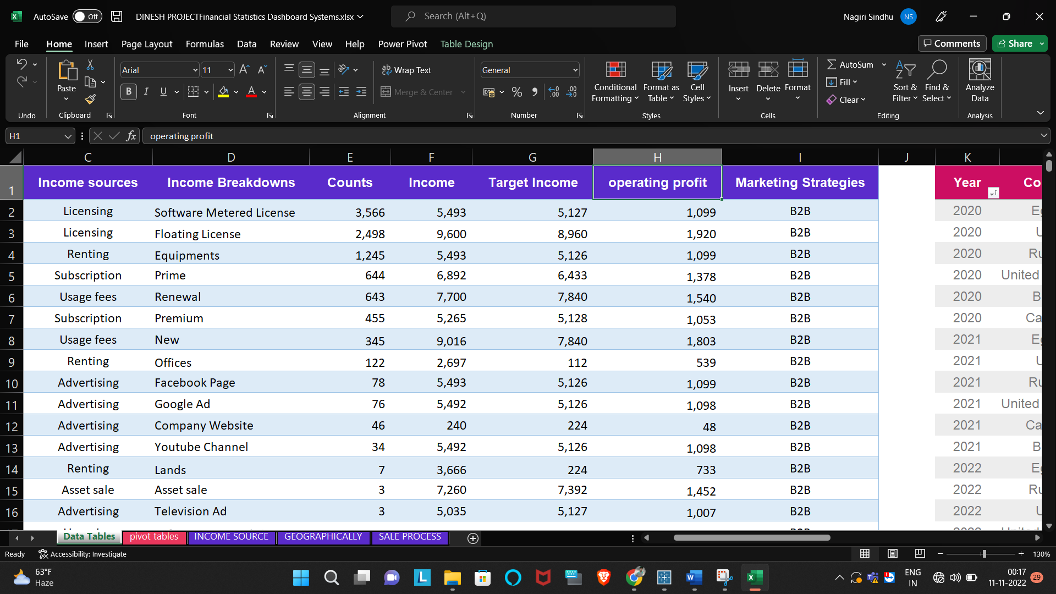

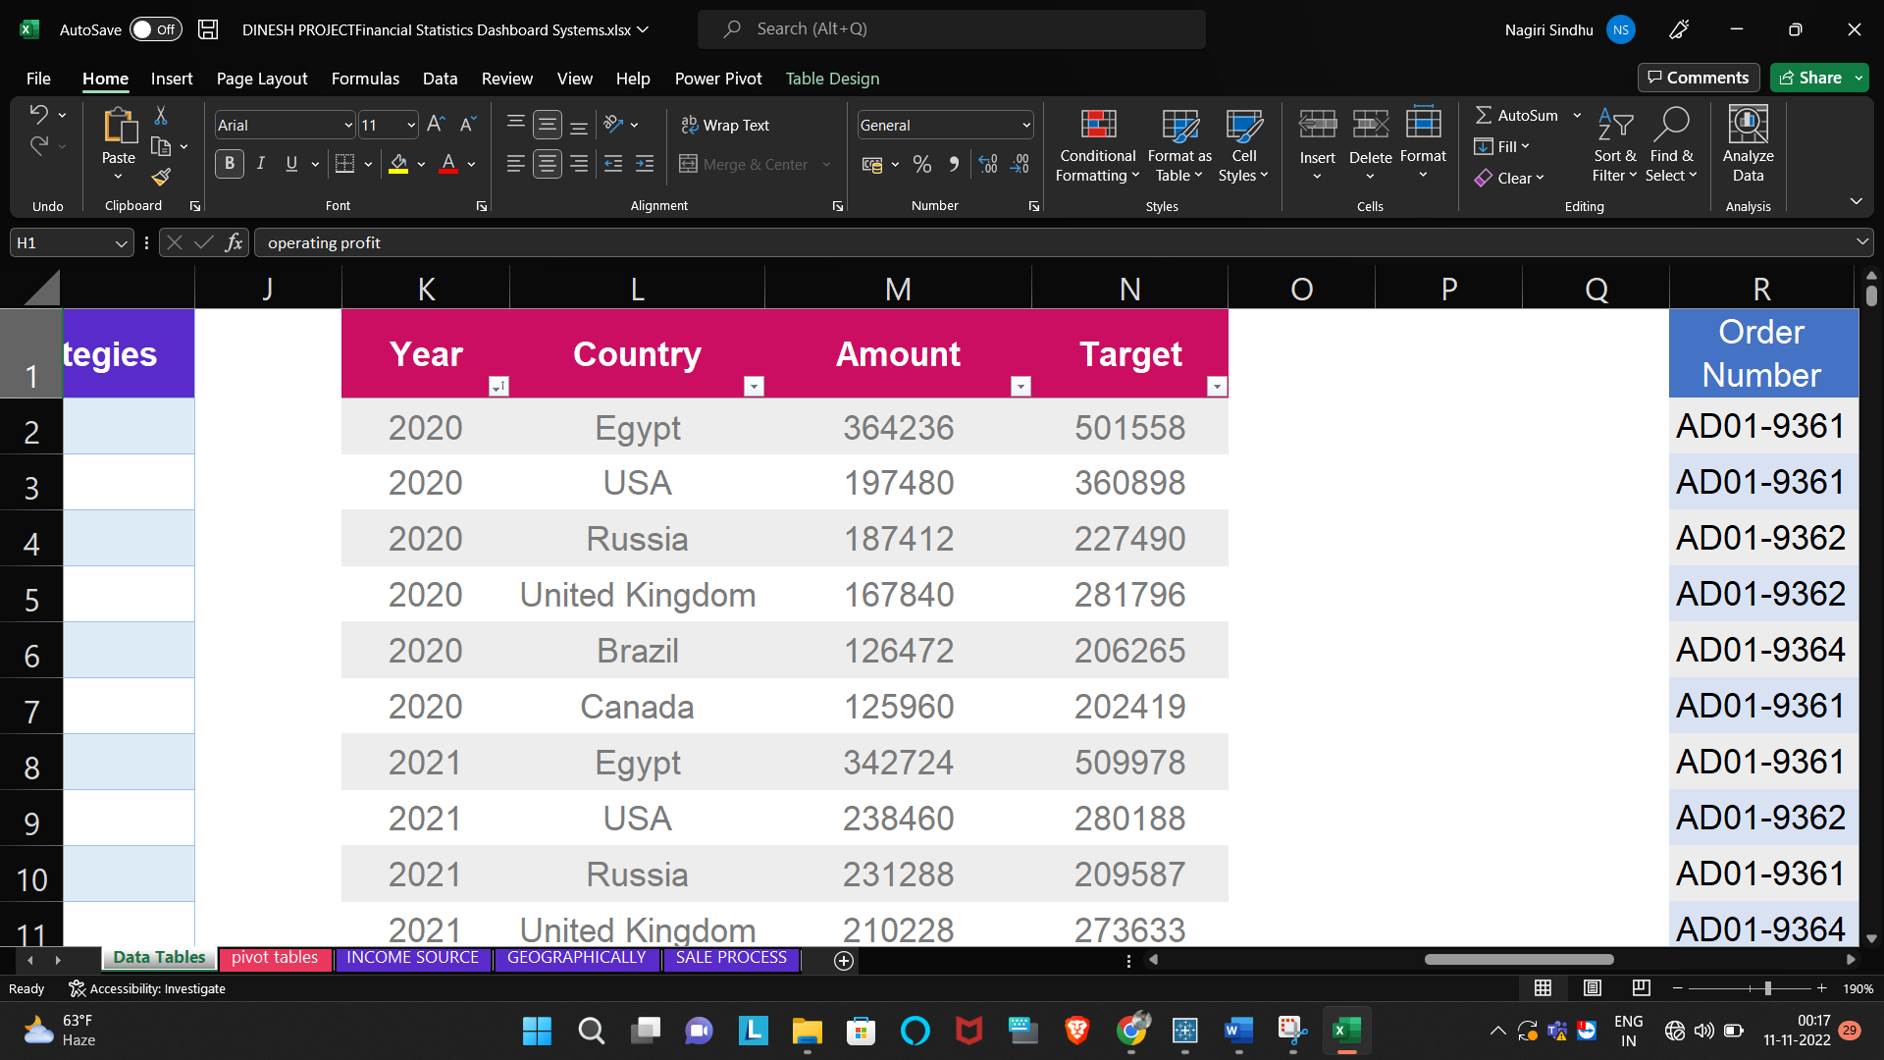

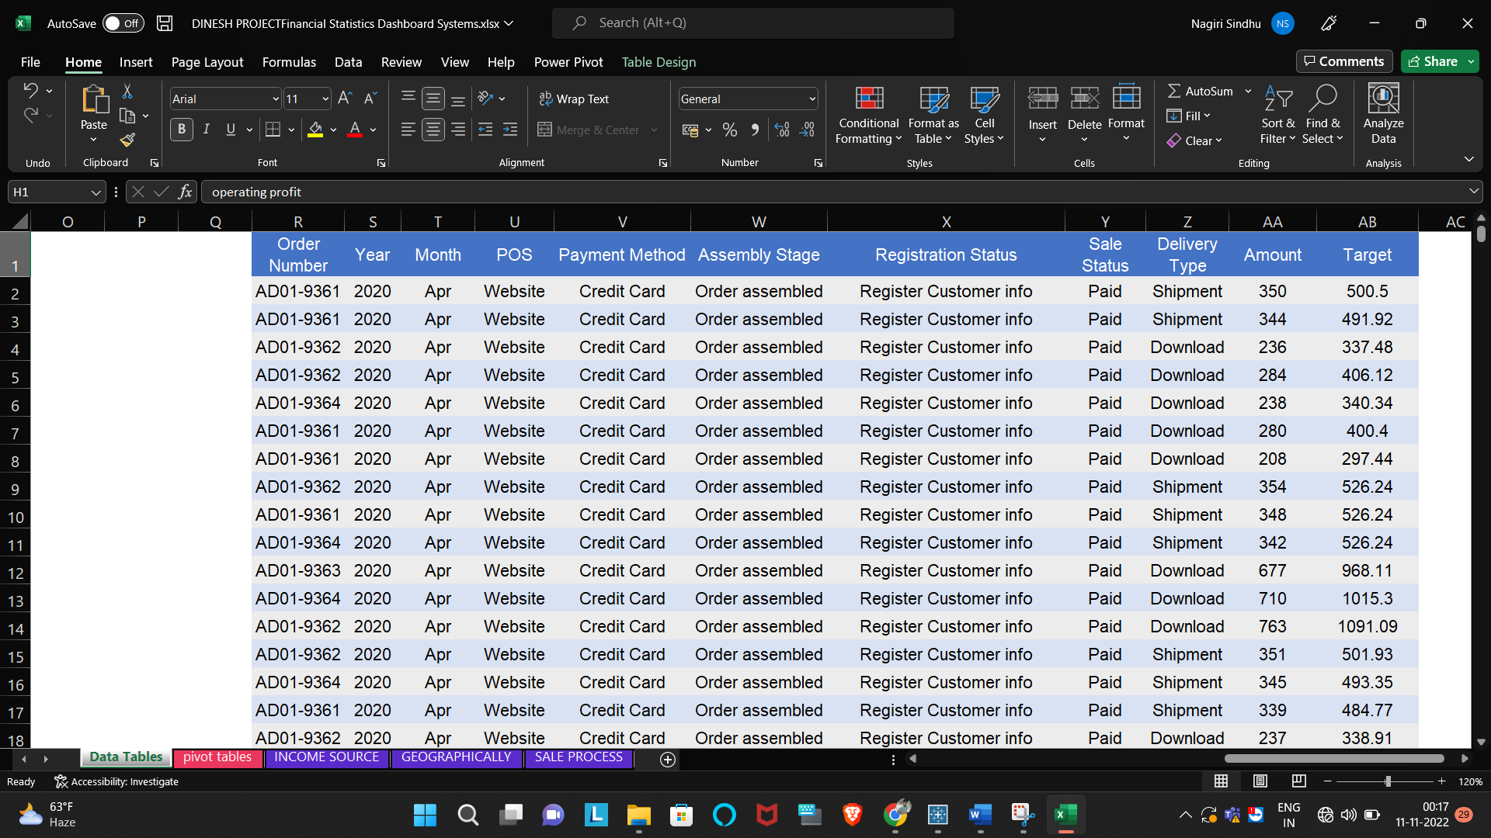

* ***ANALYSIS OF DATASET***
* **Monthly Sales and profit of each category Description:**
* By knowing about sales and profit over month we can know about the months which

are more profitable for sales and hence customize our advertising plan to increase the sales even more. After finding out the sales and profit we visualize the result with the help of a stacked bar graph.

* We have to create a pivot table. No specific functions are used. We then put the priority c and count of their respective sales in the columns of the pivot table.
* **Visualization:**

* The results are then visualized in the form of a stacked bar graph for both profit and sales

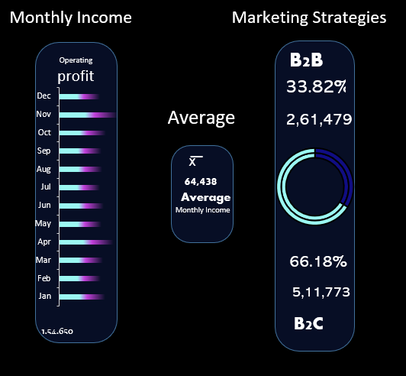

* *Operating Profit*
* *Average*
* *Marketing Strategies*

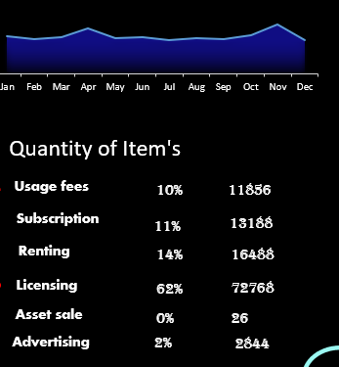

* *Quantity of item*
* *Monthly Income*

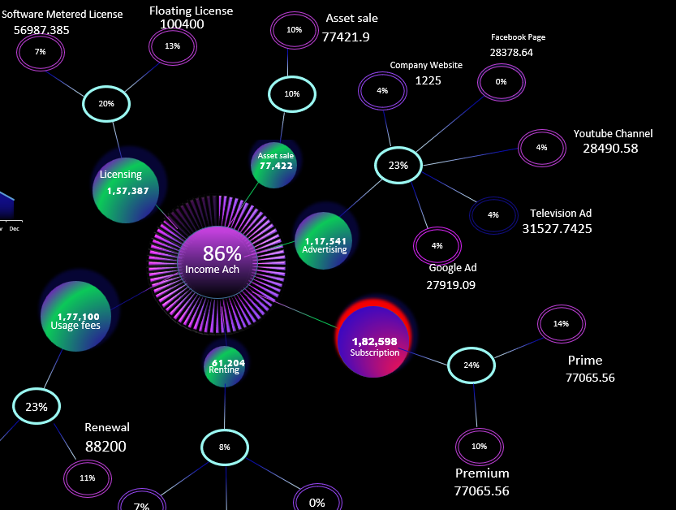

* *Income Achievement*
* *Income Breakdown’s*
* *Sum of Breakdown’s*
* *Avg of Breakdown’s*
* *Sorting from high to low*
* Analysis results

* *Total Financial Statices amount in $*
* *Country will sort by top to low*

* *Sales percentage*

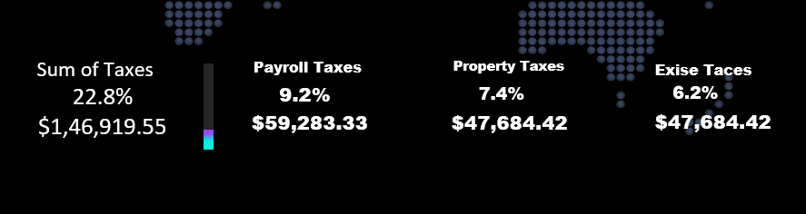

* *Sum of taxes in $*
* *Sum of taxes in %*
* *Payroll taxes in $*
* *Payroll taxes in %*
* *Property taxes in $*
* *Property taxes in %*
* *Exise taces in $*
* *Exise taces in %*

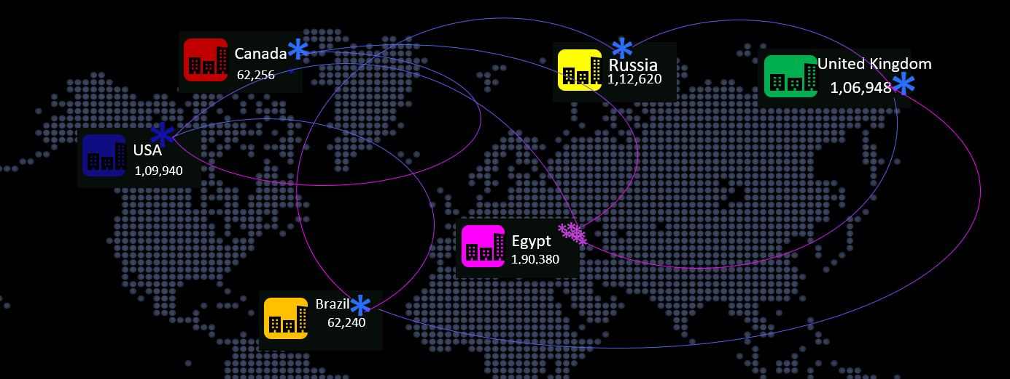

* *All country income*
* *The first country is displayed with pink color*
* *Remaining all displayed in blue color*
* *In every year country income will change*

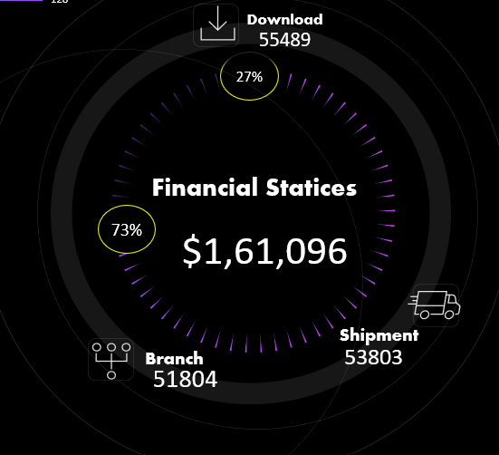

* *Delivery types*

*1.Download*

*2.Shipment*

*3.Branch*

* *In every year the delivery types will increase and decrease.*

* *Sum of amount in delivery type*

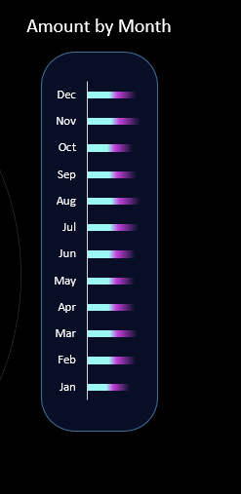

* *Amount by each month*

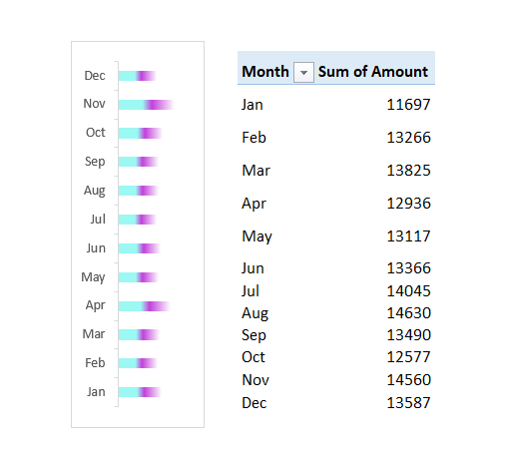

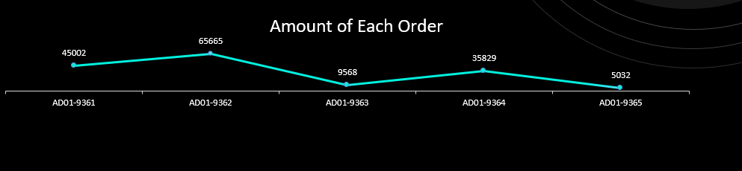

* *Each order income*

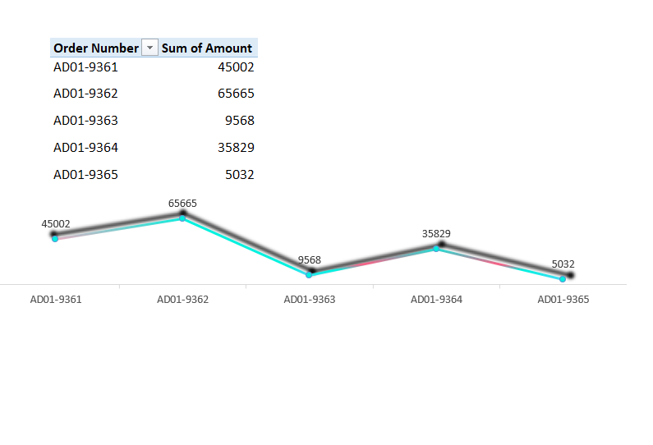

* *List of all order*
* *Line chart*

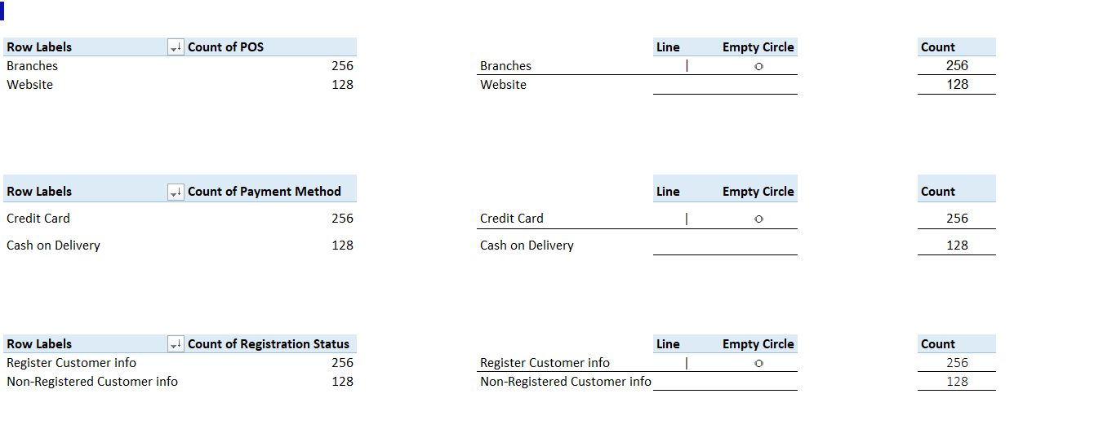

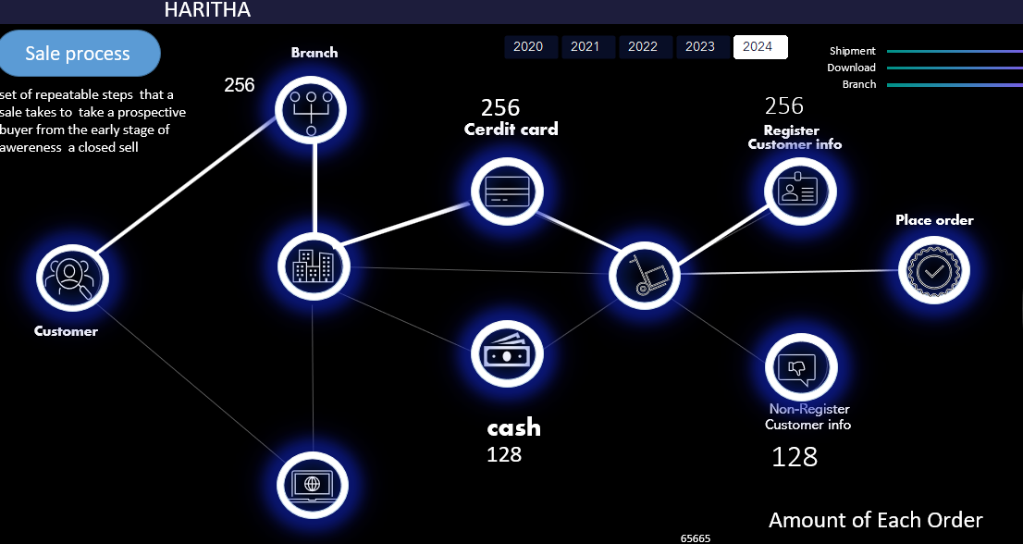

* *Count of POS*
* *Count of Payment method*

*1.Cerdit card*

*2. Cash*

* *Count of Registration Status*

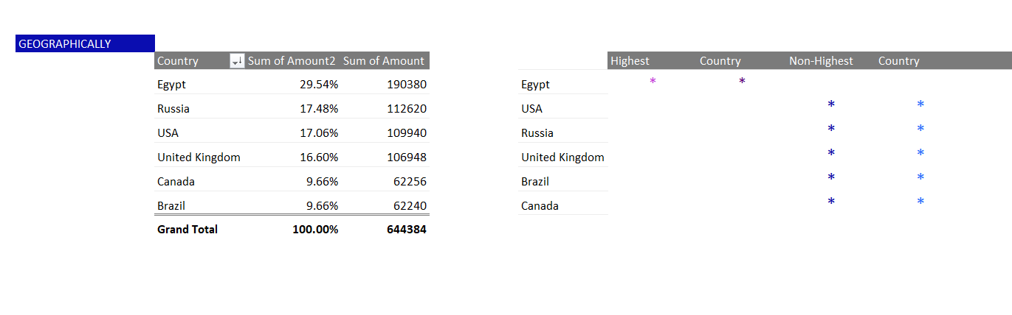

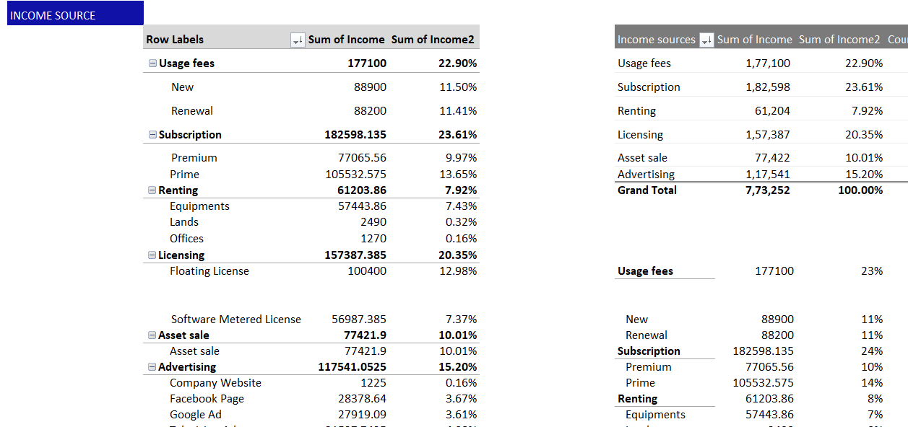

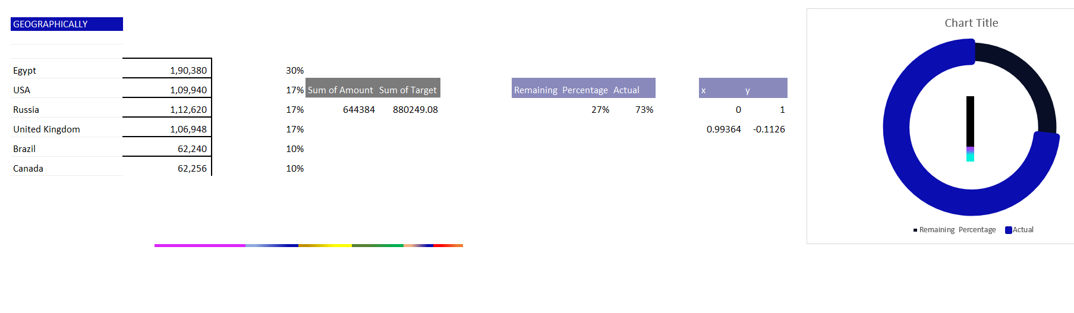

* Functions and Formulas
* *IF (J7=MAX ($J$7: $J$12), ” ”, J7)*
* *IF (J7=MIN ($J$7: $J$12),” ", J7)*
* *VLOOKUP*
* *IFERROR (AVERAGE (Y7:Y18),"")*
* *=IFERROR(VLOOKUP(CG7,$BT$6:$BV$12,3,0),"")*
* *100%- CN3*
* *ALT + =*
* *PRODUCT*
* *SUB*
* List of Analysis with results

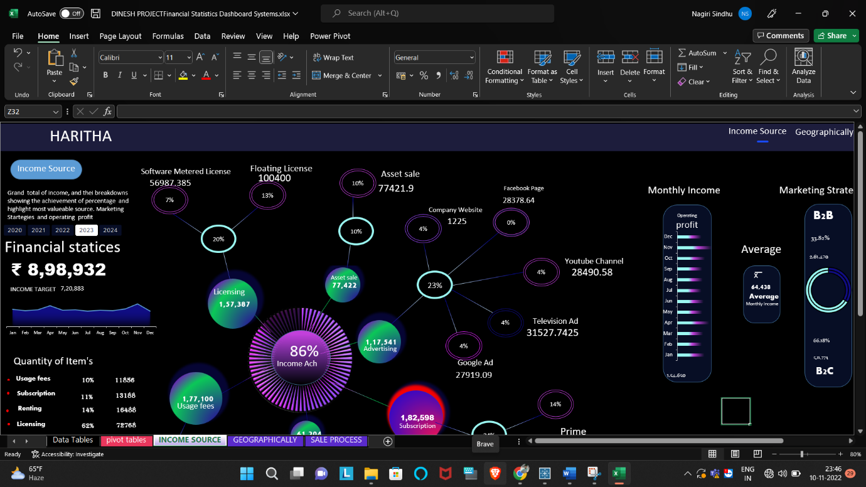

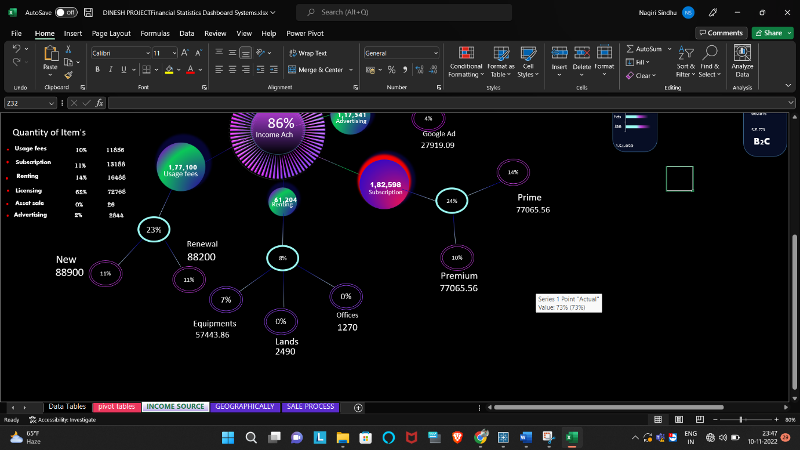

* *In every year financial statices is changing*
* *Monthly income is changing from year to year*
* *Income percentage ach.*
* *Income Sources*

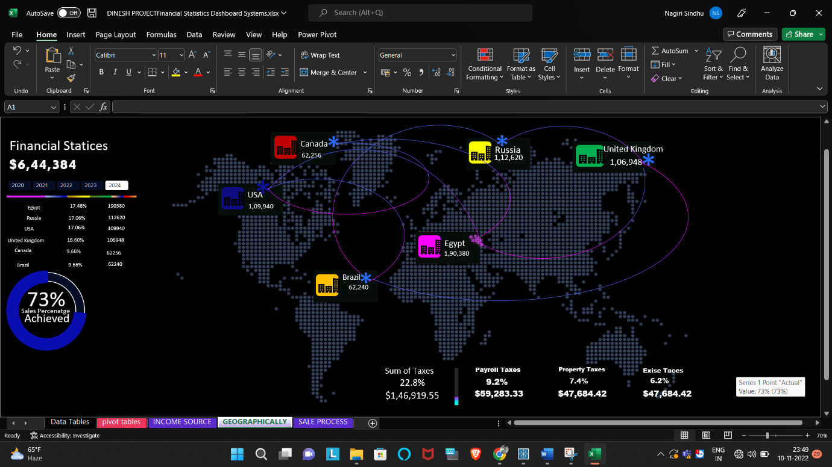

* *Financial Statices in $*
* *Country income*
* *Highest country income in pink \**
* *Sum of taxes in $*
* *Sum of taxes in %*

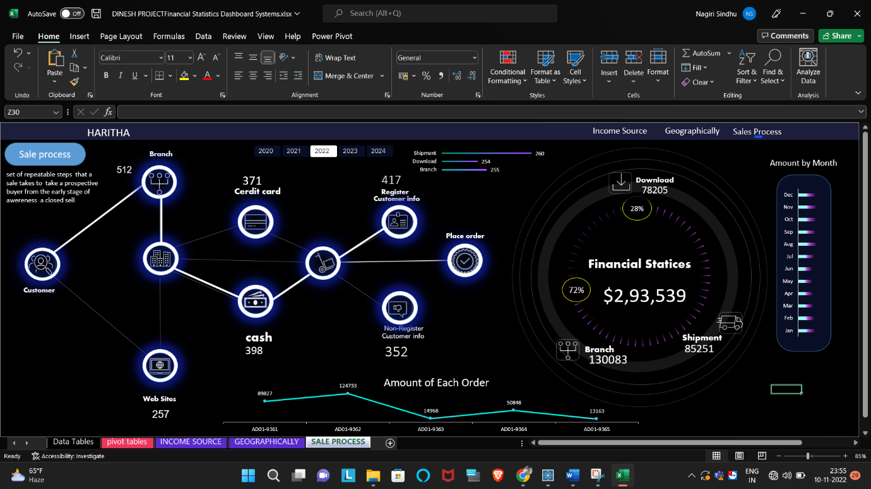

* *Order Amount*
* *Monthly income*
* *Delivery types*
* *Customers*
* *Payment method*
* *Place order*
* References
* [*https://www.other-levels.com/blogs/datasets?page=4*](https://www.other-levels.com/blogs/datasets?page=4)
* [*https://www.other-levels.com/blogs/datasets?page=3*](https://www.other-levels.com/blogs/datasets?page=3)
* [*https://www.other-levels.com/blogs/datasets?page=2*](https://www.other-levels.com/blogs/datasets?page=2)
* [*https://www.youtube.com/watch?v=f9CF1a4B9cE*](https://www.youtube.com/watch?v=f9CF1a4B9cE)
* [https://youtu.be/FuC0V_nKQW8](https://www.youtube.com/watch?v=FuC0V_nKQW8&t=0s)
* [https://youtu.be/z26zbiGJnd4](https://www.youtube.com/watch?v=z26zbiGJnd4&t=0s)